**Tasks**

**• 1. Take any integer as input, if the number is greater than 5 print it**

**1. If a>5, print a**

**2. Else if a=0,then Halt**

**3. Else if a<5,then halt**

**SOLUTION:**

in

sto 98

lda 98

sub 96

brz 09

brp 07

hlt

lda 98

out

hlt

*96

dat 005

**Output:**

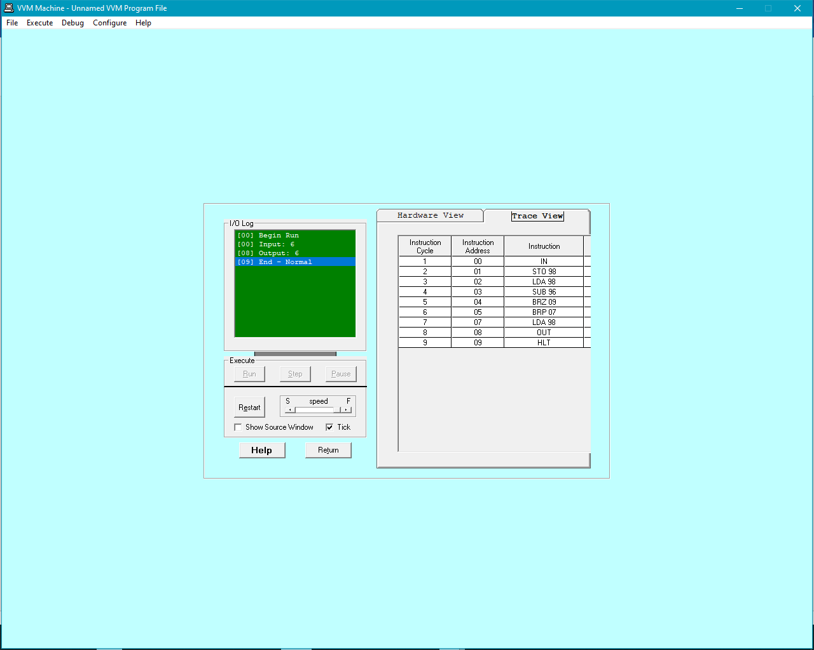

**2. Take two numbers as input and print the larger number.**

**SOLUTION:**

in

sto 98 6 4

in

sto 99 4 6

lda 98 6 4

sub 99 6-4=2 4-6 =-2

brp 10

lda 99

out

hlt

lda 98

out

hlt

**OUT{UT:**

